|  |  |  |  |
| --- | --- | --- | --- |
| |  |  |  | | --- | --- | --- | | |  |  | | --- | --- | | מצגות מטח   |  | | --- | | המצגות שפותחו עבור חונכים במסגרת תכנית נחשון לכיתות י-יא שודרגו וזמינות לשימושכם ללא עלות **במשך כל שנת הלימודים תשע"ח.** | | | |
| |  |  |  | | --- | --- | --- | | |  |  | | --- | --- | | |  | | --- | | [**למצגות בנושא גוף האדם >>**](http://trailer.web-view.net/Links/0XA9B03BA22197F4C8A179B0BFC554CE592454BAC293BDA9DEC44AB3296E5A41713642AABC2B7EAE53680294B934435030880F5C01F08B3906A6F11F591FF736C1552835B8FF6C759D.htm) | | | |

|  |  |  |  |
| --- | --- | --- | --- |
| |  |  |  | | --- | --- | --- | | |  |  | | --- | --- | | |  | | --- | | [**למצגות בנושא התא >>**](http://trailer.web-view.net/Links/0XB8AE687B181D382A9D5B1CDBFC115F549A314045FE05F85CF0F9AC4E8701E041CFC0BD3EB6E14C7F680294B934435030880F5C01F08B3906A6F11F591FF736C1552835B8FF6C759D.htm) | | | |
| |  |  |  | | --- | --- | --- | | |  |  | | --- | --- | | |  | | --- | | [**למצגות באקולוגיה >>**](http://trailer.web-view.net/Links/0XA1F9E52E53323DD5AE30C12CB8BF5F7592EEAA78A0117659ED9AED4227DFB30CD857205BC69E5023680294B934435030880F5C01F08B3906A6F11F591FF736C1552835B8FF6C759D.htm) | | | |

|  |  |  |  |
| --- | --- | --- | --- |
| |  |  |  | | --- | --- | --- | | |  |  | | --- | --- | | |  | | --- | | [**למצגות בביולוגיה בנושא פרקי העמקה >>**](http://trailer.web-view.net/Links/0X7811983E8641148423DB62DE38A04062F6BCB3EE258546A06FF983089C4E54B58D62C715CCC6DE0A680294B934435030880F5C01F08B3906A6F11F591FF736C1552835B8FF6C759D.htm)  <http://productplayer.cet.ac.il/Homeostasis>  <http://productplayer.cet.ac.il/ScienceCell> | | | |

<http://productplayer.cet.ac.il/Ecology>

[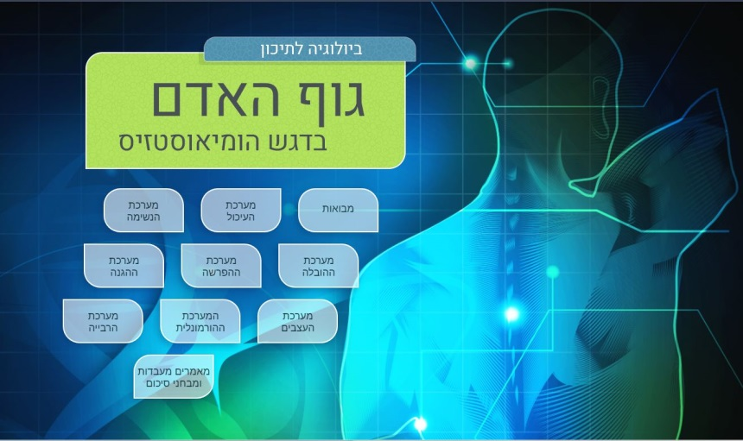](http://productplayer.cet.ac.il/Homeostasis)

[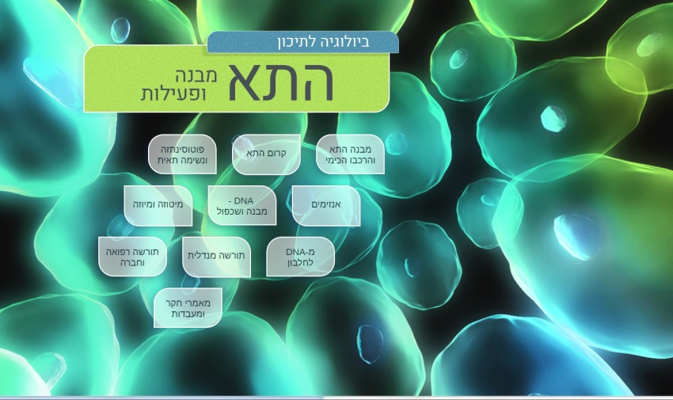](http://productplayer.cet.ac.il/ScienceCell)

[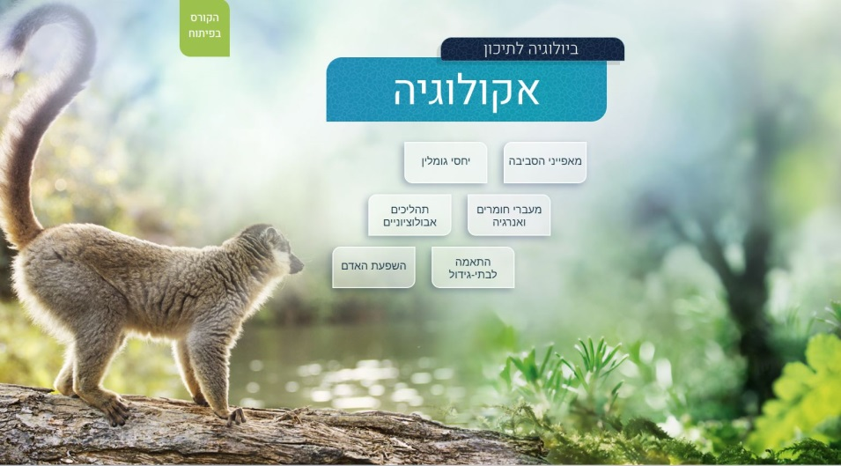](http://productplayer.cet.ac.il/Ecology)